Asia-China-Gōng / kung1 (觥) ritual bronze wine pitcher, Shang and Zhou dynasties ca. 1700 to 900 BCE.
Case 5-Asia-China-Symbolic Imagination-RJC

The Chinese Symbolic Imagination

Animals have always figured prominently in the Chinese symbolic imagination from prehistoric Rock Art to finely crafted objects of the historic period. Reasons behind the selection of some animals above others remains fascinating as animals were seen as embodying numinous powers in nature.
Numinosity in Chinese Philosophy

Animals in Chinese Imagination
Shan Ji
The frequency of certain animals appears to have been established in the Shang Period of the Bronze Age with the tiger, the muntjak deer (with the so-called bottle horns), the sika deer with branching antlers, the water buffalo with curved horns, the elephant, various birds, tortoises and turtles (see von Erdberg 1992) all of which were conjoined in different combinations in ritual Shang bronze wine Gongs.

The Chinese Dragon Identified

Although the dragon is one of the most ubiquitous creatures that one encounters in Chinese folktales and myths, its origin has largely gone unnoticed. This secretive, nocturnal creature emanated from the lower Yangtze River and its tributaries and aong th southern China coast during the Neolithic Period of China c 5000 BP

Alligator sinensis

Now it just so happened that there was one animal, a reptile, that was indigenous to the waters of the lower Yangtze and actually spanned an area quite a bit north as well some 5000 years BP -- alligator sinensis.

This was a hardy reptile that had emigrated via the Bering land bridge during one of the glacial maxima, and had settled here in southern China amidst verdant waters. ????It was an isolated species that had cousins who were found in the verdant swamps of the areas of modern Vietnam and Cambodia,

Relationship between the alligator and the true crocodile

but there they were true crocodiles. So the Chinese version of this crocodilian was distinctly an alligator although diminutive in size when compared with its New World relative.
Some writers have associated the Chinese alligator with the Chinese dragon,^{[14]} the creature in Chinese mythology; the alligator is thought to have been the inspiration for it.^{[48]} The theory that the Chinese dragon was a mythological version of the Chinese alligator was widespread during the early 1900s, with the idea having later been revisited by John Thorbjarnarson and Xiaoming Wang.^{[49]} According to The New York Times, the association with the "beneficent" mythological creature is an advantage for the species.^{[24]}
Unlike dragons in myths of the Western Hemisphere, Chinese myths portray its dragon as a symbol of "royal power and good fortune," frequently helping and saving people. The Chinese dragon is able to fly and swim;^{[24]} however, unlike dragons in the Western Hemisphere, it does not have wings. The "relatively innocuous" behavior of the Chinese alligator is believed to have been an influence for the helpful nature of the dragon.^{[48]} The fact that the alligator ends its hibernation when the rainy season begins and returns to its burrows when the rainwater in rivers recedes, as well as the fact that it lives in bodies of water, may be the reason for the dragon's portrayal as a water-related mythological creature.^{[48][49]} Alligator drums may have been used to simulate the species' vocalizations during the mating season, which humans associated with the dragon's "power of summoning rainclouds."^{[49]} Tu long, which was previously a common name of the Chinese dragon in China, translates to "earth dragon" in English.^{[24][49]}

In Neolithic China and in its succeeding eras down to the Han, there was a belief that the appearance of dragons bring about a fall of rain. Was there any truth to this belief? It was certainly a question that was being asked in the Confucian era when the rationalist critic

Wang Ch'ung (27 - 100 CE) acceded to the existence of unexplained phenomena in the
Lun-heng (論衡, "Discourse balance") ca. 80 CE, a compilation of critical essays on natural science, Chinese mythology, philosophy, and literature. So it may be affirmed that by this date the dragon principle was rationally accepted as verified by the latest scientific methods available.

When reference is made to the crocodile in Chinese sources, the reference is to the one genus of Chinese Crocodilia, Alligator sinensis (揚子鱷, yáng zǐ è) and not to the crocodile, (subfamily Crocodylinae) or true crocodiles, large aquatic tetrapods that live throughout the tropics in Africa, Asia (exclusive of China), the Americas and Australia. The Crocodilia (or Crocodylia) is the Latin order of large, predatory, semi-aquatic reptiles that appeared 83.5 million years ago in the Late Cretaceous period. Crocodilia are the closest living relatives of birds and both are the only known survivors of the Archosauria, that also includes all extinct dinosaurs, extinct crocodilian relatives, and pterosaurs. There have been no true crocodiles in China.

Alligator sinensis is one of only two known living species of Alligator, which is now native only to the lower reaches of the Yangtze River, along Yijiang and Taihu river-basin swamps and in the provinces of Jiangsu, Zhejiang, and Anhui. However, in the period of the Liangzhu culture (300-2250 BCE) its range extended from the lower Yangtze River and along the coast of southern China.

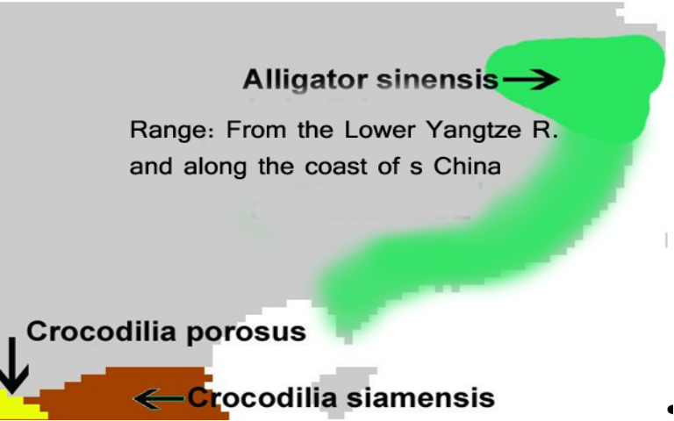
Range of Alligator sinensis coinciding with the Neolithic jade-working Liangzhu Culture, ca. 3300-2250 BCE.

Unlike its cousin, the American alligator, the Chinese alligator is armored over its entire body a feature of only a few Crocodilia, the order of large reptiles dating back 83.5 million years and named for the Greek κροκόδειλος = Ionic word for "pebble worm" from κρόκη (krókē, “pebble”) + δρῖλος (drîlos, “worm”), because crocodiles, being cold blooded, like resting on pebbles that have been warmed by the Sun. The shape of its body scales resembles the moiré pattern of curvilinear spirals that fills the interstitial surfaces on ritual bronze vessels. Hence we may infer that the Shang use of this artistic motif is related to Alligator sinensis as the archetypal embodiment of the Chinese concept of dragon, as most of the Shang bronze animal containers representative of mythical animals and dragons have this imagery emblazoned over their bodies.
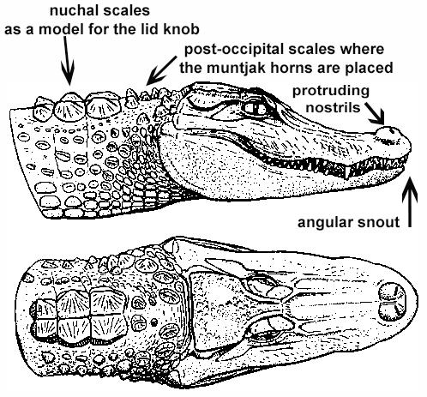
Alligator sinensis after Wermuth & Fuchs (1978)
In fact, this was from a biological and ecological point-of-view entirely reasonable. The Chinese alligators appeared when the monsoonal rains first inundated the patties: this was the harbinger of rice fructification, as the alligators scrambled up the slopes to secure a nesting site to lay their eggs that required access to at least 5 hours of sunlight each day as the females do not incubate their young.
The Monsoon as the Dragon's Time
The monsoon is a seasonal reversal of air currents accompanied by corresponding changes in precipitation (Ramage 1971). This is a seasonal change in atmospheric circulation and precipitation associated with the asymmetric heating of land and sea (Trenberth, Stepaniak, Caron 2000). Traditionally, "monsoon" refers to the rainy phase of a seasonally-changing pattern of which its alternative is a dry phase. Over oceans, the air temperature remains relatively stable for two reasons: because water has a relatively high specific heat (3.9 to 4.19 J g⁻¹ K⁻¹) (http://www.engineeringtoolbox.com/specific-heat-fluids-d_151.html), and because both conduction and convection will equilibrate a hot or cold surface with deeper water (up to 50 m.). In contrast, dirt, sand, and rocks have a lower specific heat (0.19 to 0.35 J g⁻¹ K⁻¹) (http://www.engineeringtoolbox.com/specific-heat-solids-d_154.html), which can only transmit heat into the earth by conduction and not by convection. Therefore, bodies of water stay at a more even temperature, while land temperature is more variable.
During warmer months, sunlight heats the surfaces of both land and oceans, but land temperatures rise more quickly because earth has a lower specific heat. As the earth's surface becomes warmer, the air above it expands and an area of low pressure develops. Meanwhile, water, which has a higher specific heat, remains at a lower temperature than the land, and the air above it retains a higher pressure. This difference in pressure (lower over land and higher over water) causes sea breezes to flow from the ocean to the land, bringing moist air inland. This moist air rises to a higher altitude over land and then it flows back toward the ocean (thus completing the cycle). However, when the air rises, and while it is still over the land, the air cools with the higher elevation it attains. This decreases the air's ability to hold water, and this causes precipitation over the land. This is why summer monsoons cause so much rain over land.

the Chinese Neolithic cultures of the lower Yangtze River and the area surrounding Lake Taosi. The biodiversity of this area is being threatened today by the Three Gorges Dam that has altered the river's course and its seasonal flooding. However, in the Neolithic Period rice (Oryza sativa indica) was domesticated in the lower Yangtze River drainage around Hemudu site near Lake Taosi, ca. 7000-5900 BP. The source of this domesticated rice was probably from its wild rice progenitor (Orzya rufipogon) that is prominent in the Neolithic archaeological record in monsoonal Asia from the Himalayas to Guangxi and Guangdong, while foxtail millet (Setaria italica), on was domesticated in the lower Huang Ho between 9000 and 8000 BP (An 1991, 1999; Chang 1986, Chang 1976, 1983, Crawford 1992; Crawford and Chen 1998; Glover and Higham 1996; Heu 1991; Higham 1995; Higham and Lu 1998; Ho 1977; Smith 1998; Zhao 1998).

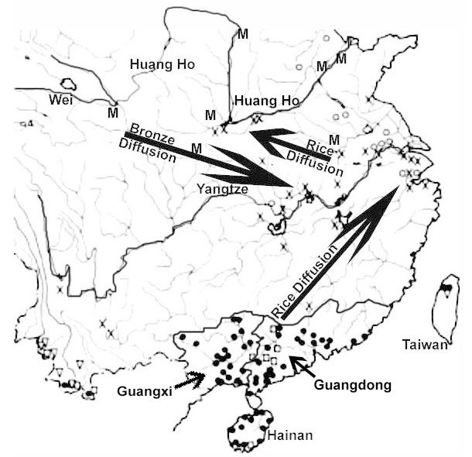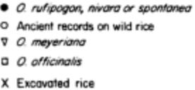
M Millet
Fig. 1. Wild and domesticated Millet and Rice in China during the Neolithic. After Chang 1983:67, Map 3.1; 71, Map 3.2.

Conversely, The spread of bronze in the succeeding Bronze Age emanated from the northwest in the Wei River valley then crossed over to the Yangtze watershed and then down to the lower Yangtze. The two movements of materiel and ideas were in synchronicity.

The dragon is a prominent numinous figure that has been associated with rainfall. Now rainfall is essential in the development of agriculture, and this connection between dragons and rainfall is recorded in ancient texts going back at least to the Han Period. Therefore, in order to invoke rainfall by sympathetic magic one was constrained to sacrifice to the dragon in order to invoke its rain-making power, a ritual of sympathetic magic as James George Frazer long ago acknowledged (Frazer 1911: 52ff.).

However, while the much later Han period was witness to the development of rationalized versions of ancient rituals of sacrifice, this sacrifice to the dragon had emanated from the Neolithic act of identifying in nature the numinous animal that was associated with life-giving rains that would soak the rice patties of the lower Yangtze and offer new life and abundance for the people. Rain was essential to the very basic staff of life, and so, the animal that was associated with this seasonal monsoon was also a very familiar animal in the lower Yangtze region.

GONGS
Gōng / kung1 (觥) are wine pitchers, that were used generally in the Shang and Zhou dynasties ca. 1700 to 900 BCE in shamanic rituals. Shamans (Wu巫) in Chinese spirituality could be both men and women, In the oracle bone script the pictograph was written
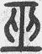
KangXi: page 325, character 19 from http://www.kangxizidian.com/kangxi/0325.gif

would enter ecstatic trances and visit the places the animals depicted on these vessels were thought to inhabit, usually inaccessible high mountain or underwater retreats. The origin of the term comes from the oracle bone script:
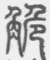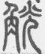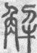
KangXi: page 1142 from http://www.kangxizidian.com/kangxi/1142.gif.

Gōngs usually have a vertical handle often in the shape of the neck and head of an animal with stylized horns, and the spout of the vessel is in the form of the head of a creature whose mouth constitutes the end of the spout.
Gōngs are decorated with taotie饕餮 designs in the form of frontal, bilaterally symmetrical, zoomorphic masks with raised eyes and no lower jaw.

The taotie design has been traced to the Liangzhu culture (3310–2250 BCE), the last Neolithic jade culture in the Yangtze River Delta, that produced large ritual jades, incised with the taotie motif. Its area of influence extended from around Lake Tai north to Nanjing, east to Shanghai and south to Hangzhou.
The two theories of the taotie motifs are ancient face masks encompassing the personae of either 1) shamans or 2) the god-kings. If the former interpretation is held they may represent faces of animals used in the sacrificial ceremonies. If the latter interpretation is held the faces were those of the god-kings who were the link between humankind and their deceased ancestors (Jordan Paper). When the taotie design is incorporated into the Gōng it appears to confirm to the first interpretation, as the wine that was placed in these vessels could be construed as the sacrificial blood of the (mythic) animal(s) depicted that was to render the spirit of the animal's vitality in those who imbibed its "blood". In the latter interpretation the imbibing of the sacrificial blood was that of the god-king with whom the participant would then enter into union.

Imbibing of sacrificial blood to attain union with the sacrificed one is an ancient theme that was incorporated into Dionysian libations and into the Christian Eucharist and retains distinct shamanic and later Gnostic overtones of attaining spiritual union with the spiritual mediator between heaven and earth.

The Atlantika Collection has several Gōngs that range from the Neolithic Liangzhu Culture to the Zhou Culture.

Alligator Gong

The first Gōng is that of a unique dragon-like creature that incorporates the taotie design that the Liangzhu Culture originated into its truncated body.

The Chinese Dragon Identified
Now it just so happened that there was one animal, a reptile, that was indigenous to the waters of the lower Yangtze and actually spanned an area quite a bit north as well some 5000 years BP -- the alligator, more specifically alligator sinensis. This was a hardy reptile who had emigrated via the Bering land bridge during one of the glacial maxima, and had settled here in southern China amidst verdant waters. It was an isolated species that had cousins who were found in the verdant swamps of modern Vietnam and Cambodia, but there they were true crocodiles. So the Chinese version of this crocodilian was distinctly an alligator although diminutive in size when compared with its New World relative.

In Neolithic China and in its succeeding eras down to the Han, there was a belief that the appearance of dragons bring about a fall of rain. Was there any truth to this belief? It was certainly a question that was being asked in the Confucian era when the rationalist critic Wang Ch'ung (27 Common Era = AD hereinafter CE to ca. 100 CE) acceded to the existence of unexplained phenomena in the Lun-heng (論衡, "Discourse balance" ca. 80 CE, a compilation of critical essays on natural science, Chinese mythology, philosophy, and literature. So it may be affirmed that by this date the dragon principle was rationally accepted as verified by the latest scientific methods available.

When reference is made to the crocodile in Chinese sources, the reference is to the one genus of Chinese Crocodilia, Alligator sinensis (揚子鱷, yáng zǐ è) and not to the crocodile, (subfamily Crocodylinae) or true crocodiles, large aquatic tetrapods that live throughout the tropics in Africa, Asia (exclusive of China), the Americas and Australia. The Crocodilia (or Crocodylia) is the Latin order of large, predatory, semi-aquatic reptiles that appeared 83.5 million years ago in the Late Cretaceous period. Crocodilia are the closest living relatives of birds and both are the only known survivors of the Archosauria, that also includes all extinct dinosaurs, extinct crocodilian relatives, and pterosaurs. There have been no true crocodiles in China.

Alligator sinensis is one of only two known living species of Alligator, which is now native only to the lower reaches of the Yangtze River, along Yijiang and Taihu river-basin swamps and in the provinces of Jiangsu, Zhejiang, and Anhui. However, in the past its range was throughout most of southern China.
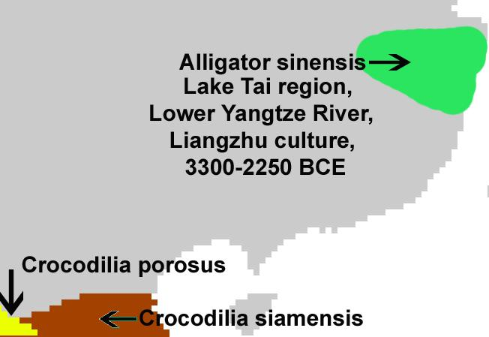
Range of Alligator sinensis coinciding with the jade-working, Neolithic, Liangzhu Culture, ca. 3300-2250 BCE.

Unlike its cousin, the American alligator, the Chinese alligator is armored over its entire body a feature of only a few Crocodilia, the order of large reptiles dating back 83.5 million years and named for the so called "pebble-worm" (κροκόδειλος Greek) texture of its body scales, which resembles the later Chinese Bronze Age Shang moiré pattern of curvilinear spirals that fills the interstitial surfaces on ritual bronze vessels. Hence we may infer that the Shang use of this artistic motif is related to Alligator sinensis as the archetypal embodiment of the Chinese concept of dragon, as most of the Shang bronze animal containers representative of mythical animals and dragons have this imagery emblazoned over their bodies.
Alligator sinensis after Wermuth & Fuchs (1978)
In fact, this was from a biological and ecological point-of-view entirely reasonable. The Chinese alligators appeared when the monsoonal rains first inundated the patties: this was the harbinger of rice fructification, as the alligators scrambled up the slopes to secure a nesting site to lay their eggs that required access to at least 5 hours of sunlight each day as the females do not incubate their young.
The Monsoon as the Dragon's Time
The monsoon is a seasonal reversal of air currents accompanied by corresponding changes in precipitation (Ramage 1971). This is a seasonal change in atmospheric circulation and precipitation associated with the asymmetric heating of land and sea (Trenberth, Stepaniak, Caron 2000). Traditionally, "monsoon" refers to the rainy phase of a seasonally-changing pattern of which its alternative is a dry phase. Over oceans, the air temperature remains relatively stable for two reasons: because water has a relatively high specific heat (3.9 to 4.19 J g⁻¹ K⁻¹) (http://www.engineeringtoolbox.com/specific-heat-fluids-d_151.html), and because both conduction and convection will equilibrate a hot or cold surface with deeper water (up to 50 m.). In contrast, dirt, sand, and rocks have a lower specific heat (0.19 to 0.35 J g⁻¹ K⁻¹) (http://www.engineeringtoolbox.com/specific-heat-solids-d_154.html), which can only transmit heat into the earth by conduction and not by convection. Therefore, bodies of water stay at a more even temperature, while land temperature is more variable.
During warmer months sunlight heats the surfaces of both land and oceans, but land temperatures rise more quickly because it has a lower specific heat. As the land's surface becomes warmer, the air above it expands and an area of low pressure develops. Meanwhile, the ocean water which has a higher specific heat remains at a lower temperature than the land, and the air above it retains a higher pressure. This difference in pressure (lower over land and higher over water) causes sea breezes to flow from the ocean to the land, bringing moist air inland. This moist air rises to a higher altitude over land and then it flows back toward the ocean (thus completing the cycle). However, when the air rises, and while it is still over the land, the air cools with the higher elevation it attains. This decreases the air's ability to hold water, and this causes precipitation over the land. This is why summer monsoons cause so much rain over land.
A Neolithic Jade Alligator-Dragon
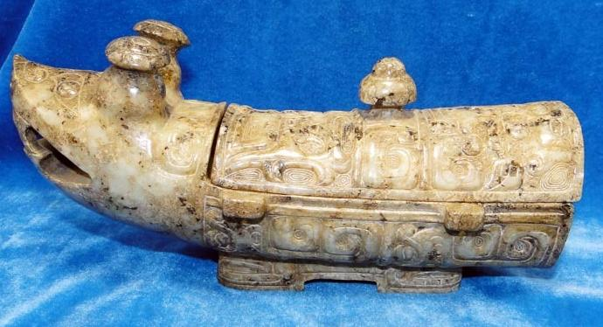
Fig. 1. Alligator-Dragon, Liangzhu Culture (3300-2250 BCE), lower Yangtze River, white jade, Atlantika Collection. The jade gong depicts an alligator with an iconography incorporating muntjak deer antlers, taotie images of apotropaic animal protectors, and "hooked cloud" motifs and fire symbols on its antlers.

A unique depiction of a late Neolithic jade alligator from the Liangzhu Culture (3300-2250 BCE) has been discovered recently that portrays the denizen of the watery deep in white jade. This jade alligator has motifs carved on its surface that relate to both the heavens (cloud motifs) and to water (reptilian motifs, perhaps alligators) and curvilinear moiré spirals. The coincidence of this imagery of heavens and water suggests the ecological demands of Neolithic agriculture in China: the need for water as predicted from the seasonal monsoonal season when the rains would ensue to ensure a productive harvest.
It is provocative that the moiré pattern of curvilinear spirals on Neolithic jade cloud motifs and on Shang Dynasty bronze vessels have this image of a cyclic pattern associated with the heavens.

A description of an entire ritual to invoke rain is included in the Ch'un-ch'iu fan-lu by Tung Chung-shu. It was in this ritual that a unique jade alligator held a prominent place for the alligator was the repository of the sacred libation that could invoke the dragon spirit and usher in the monsoonal rains.

REFERENCES
Frazer, James George. 1911.The Magic Art and the Evolution of Kings, The Golden Bough, v. 2. London: Macmillan.

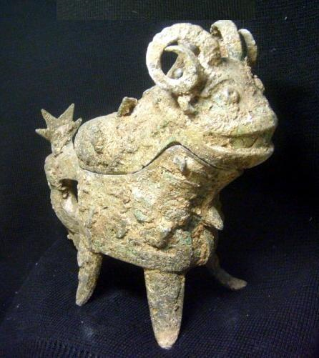
Shang Dynasty-Guang-Argali (Mountain Sheep)- Bronze-1766 BC and 1122 BCE

This Gōng 觥(wg kung1) is a ritual wine pitcher in the shape of an argali or mountain sheep dating to the Bronze Age of China. It also is decorated with bits and pieces of various animals, both real and imaginary. The

The argali was probably chosen as the animal model for this vessel because it is the largest of wild sheep and it inhabits inaccessible mountainous retreats, suggestive of the places that shamans would resort to in quest of a communion with the heavenly spirits.
The argali roams the Central Asian Highlands from central Kazakhstan in the west to the Shansi Province in China in the east and from the Altai Mountains in the north to the Tibetan Plateau and the Himalayas in the south. The argali are a species of mountainous areas, living from elevations of 300 to 5,800 m (980 to 19,000 ft). A wild argali stands at 4 ft high at the shoulder and measures up to 7 feet long (200 cm.) from the head to the base of the tail. Ewes can weigh up to 220 lbs. (100 kg.) and rams up to 400 lbs. (182 kg.).

References: Allan, Sarah. 1991. The shape of the turtle: myth, art, and cosmos in early China, SUNY series in Chinese philosophy and culture, Schenectady: SUNY Press.
Zhou Dynasty-Guang-Argali (Mountain Sheep)- Bronze-1100-1046 BCE
Height:9.8 inches，Length：11.8 inches，Width：5.1 inches，Weight:3150g
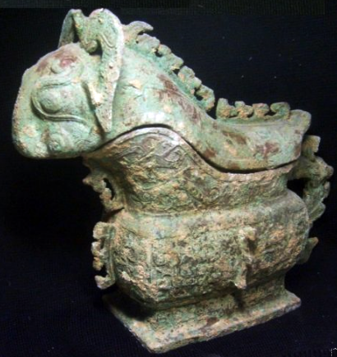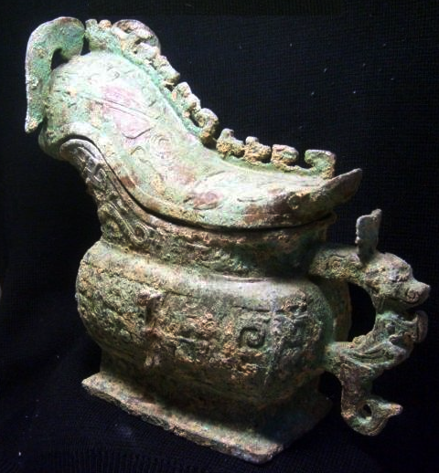

The exclusive bronze of the late Shang dynasty emperor Yung wine. To sheep in the shape of the whole body of the dragon, phoenix, birds and other myths and legends of animals auspicious decoration, showing the strong characteristics of the ceremonial vessels, surrounding decoration exquisite, fully embodies the characteristics in the ancient symbol of affluence, the sheep, meaning many fortunes.

How long is that cup of rhinoceros horn; Good are the spirits in it and soft.
When it passes around, they show no pride;
All blessings must come to seek them.
Book of Odes (i)
In the twelfth century CE Chinese scholars first began studying Bronze Age ritual vessels that were just then coming to light. Having little idea as to the specific names or exact uses of these mysterious objects, they focused their attention on their inscriptions, which represented the oldest texts known at the time. As scholars discovered clues into the names of these curious vessels, they studied surviving classical literature in hopes of learning how these objects might have been employed or what their role was in ancient ceremonies. In the instance of the bronze vessel under consideration here, no inscribed characters provided a name or shed light on its use. Hence, academicians cataloging the Song Dynasty collections made a guess and classified it as an yi or ewer.

Wang Guowei, a twentieth century scholar who did seminal research on bronzes and their inscriptions, continued the philological tradition in the study of vessel types. He believed the Song dynasty scholars were incorrect in their classification of this vessel. Wang was sure this was the siguang mentioned in the Book of Odes (Shijing), that most venerable of Chinese classics. Wang surmised that this type of vessel, bearing a horned creature on its lid, matched the passages in the Odes that read, "I will take a cup from that rhinoceros' horn," or, as in the first line of the poem cited above, "How long is that cup of rhinoceros horn." (ii).

On further study, it seems more likely that another type of vessel better fits this passage from the Odes. For the siguang of antiquity was a serving vessel, probably derived from the form of an ox horn rather than a rhinoceros. (iii)

As for this vessel, current usage favors the term gong. (iv)
The study of ancient names does little to explain the exotic shape of this gong which does not resemble a horn of any sort. With the lid removed, it resembles a gravy boat set on a ring foot (one can see why the Song dynasty scholars classified it as an "ewer").

Large birds with flaring plumes and trailing feathers, commonly identified as phoenixes, adorn both sides of this vessel and serve as the principal motif. Two serpentine creatures, often identified as dragons, climb the throat of the vessel just out of reach of the birds' beaks, suggesting a theme of combat. A different kind of bird-and-animal theme is echoed on the handle where a diminutive water buffalo with prominent snout and spreading horns serves to anchor the handle to the wall of the vessel. A small projecting hook placed low on the handle suggests the tail of a bird. There is an intimation of some ancient narrative in this strange mélange of creatures. Birds in combat with dragons and ox-headed mammals grasping birds in their mouths evoke visions of some tribal myth that remains elusive, subliminal, slightly beyond our consciousness.

The image of this vessel changes dramatically when the lid is put in place. Then, lid, bowl, foot and handle become part of a unified structure representing the body of a single creature, a three-dimensional animal conceit. The round-eyed animal at the other end of the lid, the elongated phoenix in the middle, the serpent on its crown, all the other animals on the body of the vessel, are there if choose to see them, but they serve as accessories to the dominating image presided over by the "bottle-horned dragon" set over the spout. (v) However one reads it, there is now a coherent image, like a sculpture of a single animal.

The earliest examples of the gong reveal their hybrid origins in the awkward way they meld the more traditional shape of a bronze utensil into a more sculpturesque animal form. The lower bodies of these early vessels are like two-handled bowls that have had one handle lopped off and a body that has been flattened to accommodate the addition of a spout and animal lid. Sometimes they are set on a foot-ring, sometimes on separate legs, but always the lower bodies remain constant in their use of the usual array of Shang motifs, most notably the symmetrically arranged animal mask commonly called the taotie.(vi) As a result, there was always a disturbing contrast between the compelling frontality in the arrangement of the taotie on the lower part of the vessel and the asymmetrical, directional orientation of the animal décor on the spout and cover.

That compositional tension was successfully resolved in the redesigned form of the gong as evidenced by this vessel. Here, all motifs face the same direction, accepting a common course set by the horned creature on the lid and providing a natural flow in the movement of the birds to the front of the vessel. In addition, the dense network of minute meanders and spirals (leiwen) that commonly surrounded the decorative motifs on Shang dynasty bronzes has been omitted, thus doing away with the contrast between motif and background. In its place, we see the smooth wall of the vessel resulting in a new unity of surface and, hence, a greater unity of the shape itself. Decoration is treated in the same fashion. The two creatures on either end of the lid are depicted in mask-like fashion, without any hint of bodies. Their faces seem to emerge from the background, thus reinforcing the conceit that the "body" of the vessel is also the "body" of these masked creatures. So, too, the vessel's handle is also the body of the buffalo/bird invention depicted there. Decoration takes on a new role that is subservient to shape and oriented in a way that graces the silhouette of the vessel and reinforces the animal conceit at the expense of the individual decorative motifs. Birds, dragons, snakes and animal masks merge more easily into the wall of the vessel and becomes less dominant. There is a transformational quality in this, a shifting reality in the eye of the viewer. One moment we see a simple animal form, next we see details of disparate creatures playing across its surface, making themselves known only to merge again with the whole. This kind of magical ambivalence is characteristic of a new style, one that was a dynamic departure from the more static, ornament-focused norm of the Shang Dynasty.

Changes in vessel design were not purely artistic decisions under the control of the bronze masters. The development of style was entwined with political developments of the era. The taotie and the associated motifs that ornamented the bodies of the Shang dynasty vessels, including the earlier gong, were sacrosanct, decorative devices emblematic of the Shang Dynasty itself. These potent symbols could not be cavalierly abandoned.
The emergence of the Zhou people as a new dynastic power ultimately became the catalyst for stylistic invention; new times demanded a new symbolic rhetoric. It was not just decoration that had to change; whole classes of vessels, especially those like the gu and jue that were associated with wine sacrifices, were struck from the inventory of ritual vessels. The gong, as a wine container, fell victim to the same trend within a few generations of Western Zhou rule. Thus, the Weisbrod vessel represents a special moment in the design of this new kind of vessel. Indeed, this style of gong is as emblematic of the new era, the rule and rise of the Western Zhou Dynasty, as the older style was of the Shang.

In the intervening years between the casting of this vessel and its entry into the modern world of scholarship, museums and art collecting, it has been subjected to the brute forces of the elements. The brassy bright surface of the original casting has weathered to the rich, green texture we see today. The rich patina, though not true to the original appearance, has come to be part of the aesthetic appeal of these vessels, part of what makes them antiques. Early conservationists, from the Song Dynasty down through the nineteenth century, chipped away at the patina on the surface of bronzes and waxed them to a dark, almost black color. More recently, the fashion has been to preserve something of the tone of the object as it has emerged from the ground. So, visiting a modern museum, we may encounter vessels of very different colors reflecting the taste of the times when they were restored. This vessel was also restored to something like its original condition. Minor damage was filled in following the pattern of the undamaged areas and the surface stabilized to prevent further decay. That, too, is a part of this vessel's complex history.
Reference

(i) Book of Odes, (Shijing), Sang hu, Decade of Sang Hu, the last quatrain of Ode 215 conveniently available in the University of Virginia electronic edition at URL: http://etext.lib.virginia.edu/chinese
(ii) ibid. - Odes of Zhou and the South, Juan Er, #3. For the use of a rhinoceros horn drinking cup the final stanza of Ode #154 seems the better candidate, "Let us slaughter our lambs and sheep, And go to the Halls of the Princes. There raise the cup of rhinoceros horn And wish him long life that he may live forever." The Odes of Bin: Qi Yue
(iii) A horn-shaped vessel excavated in Shanxi is illustrated in Ma Chengyuan, Ancient Chinese Bronzes, Oxford University Press, 1986, pl. 32; therein classified as a gong.
(iv) A vessel quite similar is illustrated in The Shanghai Museum of Art. Shen Zhiyu, ed. Abrams, no. 69-70, p. 151, the "Fu Yi" gong. The text describes it as a serving vessel with "a spout for pouring wine."
(v)As in the vessel cited above, which has the same kind of horns and facial structure. The "model" for this animal, if such existed, might be the Reeves deer, which has a small stumpy horn crowned by a sharp thorn-like spike.
(vi) See Jörg Trübner, Yu und Kunag, zur typologie des Chinesischen bronzen, Klinkhardt & Bierman Verlag, Leipzig, 1929, for a good selection of examples of the gong type.
Since sacrifice is at the heart of Chinese spirituality, it is now necessary to explore its origins and early symbolism in order to understand how sacrifice to the dragon came about.

The origins of sacrifice in the “Ji fa” chapter of the Liji.

The Liji, or Book of Rites 禮記 of the Zhou Dynasty ca. 1150 BCE, is one of the Five Classics in which all Chinese were to be educated. The Liji adumbrates ancient ideas of sacrifice to invoke two types of numinous forces that could be utilized to act for the benefit of the living: sacrifices to the ancestors and sacrifices to the nature spirits representing, respectively, the social and cosmic spheres both of which derive their meaning and efficacy from the ways in which humans have defined them, for these numinous forces were believed to have no intrinsic meanings aside from those which have been assigned them by human sages.

The first type of spirit force invoked is those of the dead ancestors, or ghosts鬼, for while everything on earth that lives will ultimately die, only humans remember their dead. In this process as each succeeding generation passes out of life ancestors become “ghosts” ( gui 鬼) or a hún魂 , similar to the idea of "soul" in Western thought (Liji,“Ji fa,” ICS, 122.24.4).

Sacrifice to ghosts was done in hierarchies according to the Liji: "Therefore the king erected seven ancestral temples, with an altar and level area for each. They were called: the temple for the father, the temple for the grandfather, the temple for the great-grandfather, the temple for the great-great grandfather, and the temple for the highest ancestor. At each he sacrificed monthly. The ancestral temples for the distant [ancestors] consisted of two tablets; sacrifices were offered seasonally, and then stopped. When they removed each tablet, they placed it at the altar; when they removed it from the altar, they placed it at the level area. For the altar and level area, when there was a prayer at them, they made sacrifices. If there was no prayer, they stopped. When it was removed from the level area, they were named “ghosts.” (Liji, “Ji fa,” ICS, 122.24.5)"

After the seventh generation the royal dead assumed an ontological status as “ghosts.” Further down the hierarchy, the lords were accorded only five ancestral temples, and their dead after the fifth generation assumed an ontological status as “ghosts,” while the nobles were allowed three ancestral temples, the officers two ancestral temples, and the petty officers one ancestral temple. The lowest strata of society were not allowed to sacrifice to the dead at all: “The lower offices and commoners got no ancestral temples; their dead were called ‘ghosts’ ” (Liji,“Ji fa,” ICS, 122.24.5).

Now the actual objects used in this process of sacrifice were of two kinds, and in the Neolithic period they were both made of jade, which was considered to be the most immutable and therefore spiritual substance. The first type of object was the cong, initially a short prismatic cylinder of one generational level with square or triangular sides around a hollow tube. These cong represented the generations of ancestors that were much later specified in the Liji, so that those cong with more generational levels were accorded a higher status than those with fewer levels. Initially these cong were developed on the model of the Wu or shamanic ancestor with its animal spirit helper and so the animal spirit was linked with the human ancestor in each generation. This linkage of the human and the animal suggests that those ancestors accorded the honor of being represented were themselves Wu or shamans.

Sacrifices to the ancestors in the Liangzhu culture (良渚文化; p Liángzhǔ wénhuà) (3400–2250 BCE).
The Liangzhu Culture was a late Neolithic jade-working culture in the lower Yangtze River Delta with an area of influence extending from Lake Tai north to Nanjing, east to Shanghai and south to Hangzhou. Élite burials with jade, silk, ivory and lacquer artifacts indicate that this was a hierarchical culture, with pottery in the burials of peasants. The type site at Liangzhu was discovered in Yuhang County, Zhejiang and initially excavated by Shi Xingeng in 1936.
The Y chromosome from 56 archaeologically excavated human remains of the Liangzhu culture had a high frequency of the O1 haplogroup, linking this culture to modern Austronesian and Daic populations and demonstrating the genetic foundation of the multiple origins of the Chinese civilization. (Li H, Huang Y, Mustavich LF, Zhang F, Tan JZ, Wang LE, Qian J, Gao MH, Jin L. Y chromosomes of prehistoric people along the Yangtze River. Hum Genet. 2007 Nov;122(3-4):383-8.)
The culture possessed advanced agriculture, included irrigation, paddy rice cultivation and aquaculture. Houses were often constructed with stilts on rivers or shorelines.
The jade from this culture is characterized by finely worked large ritual objects, commonly incised with the taotie motif. The most exemplary artifacts from the culture were its cong (cylinders). The largest cong discovered weighed 3.5 kg. Bi (discs), Yue axes (ceremonial axes), and pendants were also found, designed with engraved representations of small birds, turtles and fish. Many Liangzhu jade artifacts had a white milky bone-like aspect due to its tremolite rock origin and influence of water-based fluids at the burial sites, although jade made from actinolite and serpentine were also commonly found.
A Neolithic altar from the Liangzhu culture, excavated at Yaoshan in Zhejiang, demonstrates that religious structures were elaborate and made of carefully positioned piles of stones and rock walls: this indicates that religion was of considerable importance. The altar has three levels, the highest being a platform of rammed earth. Three additional platforms were paved with cobblestones. There are the remains of a stone wall. On the altar are twelve graves in two rows.^{[1]} A new discovery of ancient city wall base relics was announced by the Zhejiang provincial government on November 29, 2007. All the relics previously identified were parts of city construction. It was concluded the site was the ancient capital of the Liangzhu Kingdom, whose influence spread as far as modern-day Jiangsu, Shanghai, and Shandong Provinces. A new Liangzhu Culture Museum was completed in 2008 and opened late in the year. It is 17.5 kilometers north-west of the north-east corner of West Lake in Hangzhou.
Liangzhu congs are comprised of a square exterior prism or half a square prism enclosing a circular inner column. It has been thought that the square represents the earth and the interior column was a conduit to communicate with the heavenly spirits. The square exterior is comprised of double, repeated cartouche-like panels on each of the four corners. The upper panel is thought to represent an anthropomorphic mask, while the lower panel is thought to represent an animal mask. The juxtaposition of an animal and a human mask suggests that the human is in a shamanic relationship with an animal power. This iconography undoubtedly harkens back to a pre-Neolithic period when shamanic imagery was the symbolism of hunter-gatherers and was the imagery that was inscribed on petroglyph panels. Hayashi Minao argues that the name of the cong/tsung derived from zhu/chu meaning "master" which we expand to "master of animal powers" (Hayashi 1990:6).

The color of the Liangzhu cong also hints at its Earth derived symbolism. The late Zhou ritual classic, Zhou Li p, Chou Li wg (周禮) in the middle of the 2nd century BCE, compiled some three thousand years after the present example was manufactured, stipulated that "jade is used to make the six instruments by which the king worships Heaven and Earth and the four quarters [Spring, Summer, Autumn, Winter]. ... by the yellow cong (wg), tsung (p), Earth [is worshipped]" (Biot 1851).

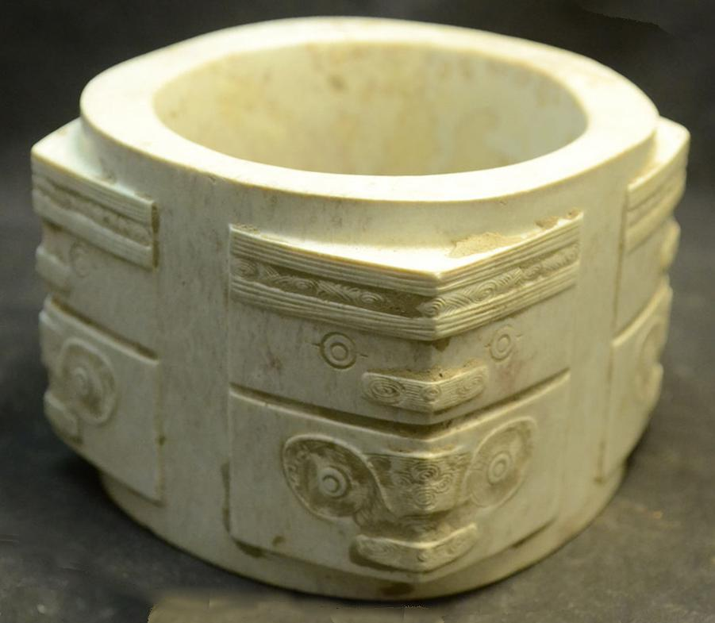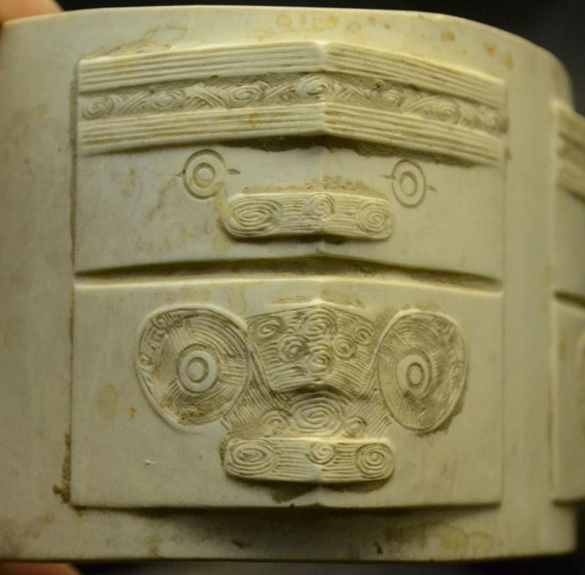
Fig. 2. Cong prismatic cylinder, jade, early Liangzhu Culture, ca. 3200 BCE, height 2.375, width 3.25 in., depth 3.25 in. , hole diameter 2.5 in., weight 425gm. Each of the four ancestor masks on top have parallel lines representing a feathered headdress. The eyes are concentric circles with dashes forming the corners of the eyes. A thin bas relief rectangle with rounded corners forms the mouth. The animal mask below is comprised eyes formed by two concentric circles with large oval eye ridges and a prominent truncated prism for a nose. A thin bas relief rectangle with rounded corners forms the mouth. The cylindrical core which represents the numinous Heaven Yin energy is combined with a square collar representing Earth energy exterior formed by four prismatic corner prisms that have bas-relief human and animal masks, representing numinous Yang energy.

The cong in Fig. 2 cong may have been once more yellow, and its present creamy off-white color is thought to have been produced by minerals leaching into the jade during the first weeks after interment of the deceased. This two-tier cong has a wide opening that is approximately 7/8 of the implement's outer diameter. The significance of this proportionality is unknown. According to Hayashi Minao, a Japanese expert of Liangzhu jades, two-tier congs are the earliest and were produced in the early Liangzhu period, ca. 3200 BCE, based on archaeologically excavated examples (Hayashi 1973; Hayashi 1990:6). Later Liangzhu congs were elongated with multiple tiers. In the early Liangzhu period the central hole was characteristically wide, as in this example.
References:
Biot, Jean Baptiste. 1851. Le Tcheou-li: ou, Rites des Tcheou. Paris: Imprimerie nationale, 1851. 3v.
Hayashi Mineo. 1990. On the Chinese Neolithic jade Tsung/Cong, Artibus Asiae, 50(1/2):5-22.
Hayashi Mineo. 1973. Toho Gakuho 45:1-57.
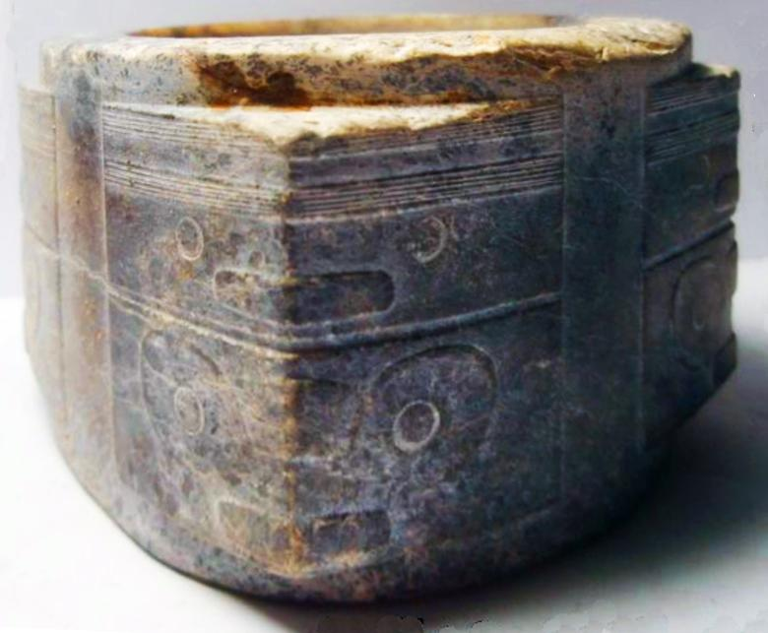
Fig. 3. Cong prismatic cylinder, jade, early Liangzhu Culture, ca. 3200 BCE, Jade, 8.5 cm. x 8.5 cm. x 5.6 cm. Atlantika Collection.
This specimen is noteworthy since it shows the effects of it having been used for a considerable period of time as the upper surfaces show abrasion. The two tier Cong type is a refined expression of the Liangzhu style. A half Cong with similar abstract and stylized imagery is in the Norton Museum of Art , West Palm Beach, Florida (Childs-Johnson and Fang 2009: 106).

References:
Childs-Johnson, Elizabeth and Fang, Gu. 2009. The Jade age: Eartlu Chinese jades in American Museums. N.p.: Science Press.

As cong iconography developed the representation of the Wu ancestor became more elaborate:
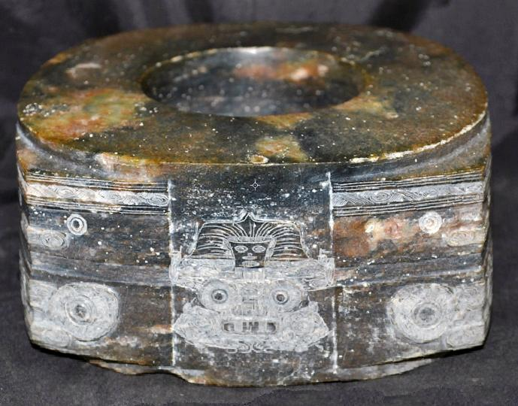
Fig. Cong prismatic cylinder, jade, mid Liangzhu Culture, ca. 3000 BCE, Jade 13.5 cm. Atlantika Collection

The development of more tiers of mask imagery followed from the double tier. This may represent an expanding hierarchy as Liangzhu culture expanded.

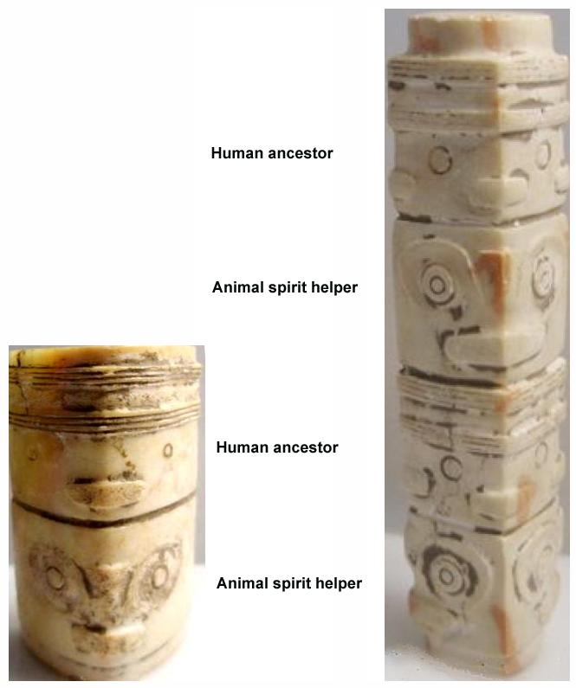
Fig.. The development of the Jade cong, mid Liangzhu Culture, ca. 3000 BCE. Left, diminutive triangular prism with one ancestral level (3.4 cm., 3 cm., 5.8 cm.) and right, diminutive square prism with two ancestral levels (1.4 cm., 1.4 cm., 7.8 cm.). Both examples Atlantika Collection. Right cong: White jade cong-shaped bead with four tiers of masks and with pink patches. A long tube with a square cross-section and a central perforation which has been drilled from both sides . There is a circular rim at each end. There are four tiers of two anthropomorphic masks and two animal masks, but one of the animal masks is turned at a right angle to the rest.. The surface has a highly polished patina indicative of long use. As the congs were elongated the central hole, generally, was narrowed.
A comparable example is from Yaoshan that was excavated in June, 1987 (Lu Wenbao 1998: no. 54, pp. 98).
References:
Lu Wenbao. 1998. Cong-shaped bead. In Liangzhu Culture Museum, ed., The dawn of Chinese civilization: Jades of the Liangzhu culture. Hong Kong: Liangzhu Culture Museum and The Art Museum, The Chinese University of Hong Kong

As congs became more elongated the original paring of animal and anthropomorphic masks became obliterated, with only the human mask surviving.
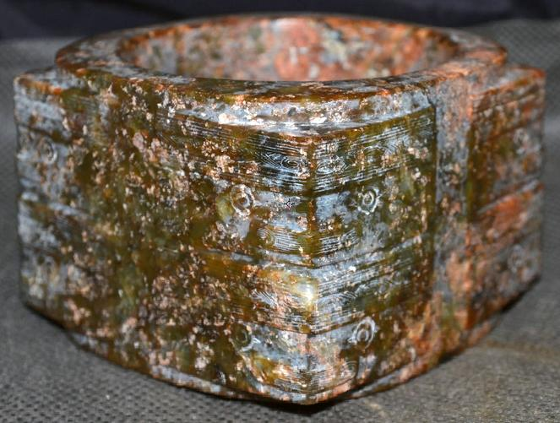
Cong prismatic cylinder, jade, late Liangzhu Culture, ca. 2500 BCE, Jade, 8 cm. x 8 cm. The ancestral mask is composed of rectangular reliefs composed of single circles for eyes, a concave nasal ridge, double horizontal rectangular bands (separated by a distinct indentation) for the headdress, and a single horizontal rectangular band (about half the length of the headdress) as a mouth. Atlantika Collection.
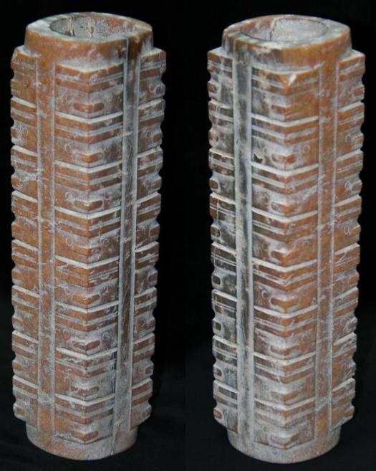
Cong prismatic cylinder, jade, late Liangzhu Culture, ca. 2500 BCE, Jade, 6.5 cm., 6.5 c., 24.3 cm. Atlantika Collection. This cóng has eight tiers of anthropomorphic masks and probably corresponds to the specification in the Liji 2000 years later as ancestral generations. It has the tapered prismatic design with the largest tiers being at the top of the prism.
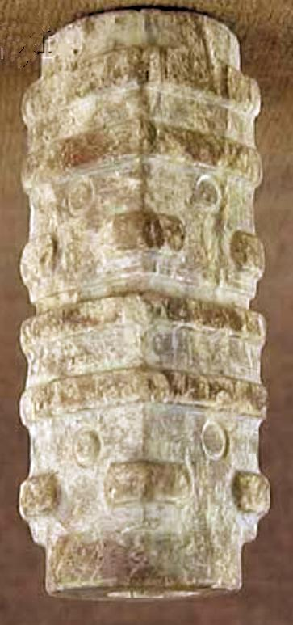 SHAPE \* MERGEFORMAT 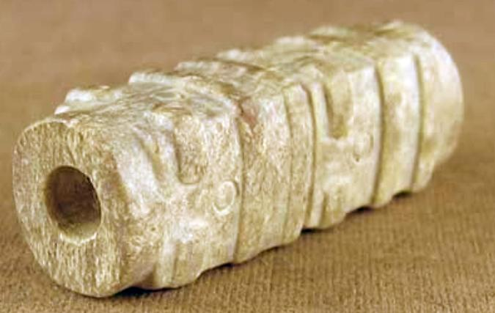

Liangzhu Culture, cong-shaped bead, ivory jade with brown patches, with a square cross-section and a central perforation , which has been drilled from both sides. The decoration on the exterior is two tiers of simplified anthropomorphic masks; height 1.8 in., width 0.65 in.; thickness 0.6 in.
A comparable example was excavated from Huiguanshan in Feb. 1991 (Lu Wenbao 1998: no. 56, pp. 98-99).
Ref.: Lu Wenbao. 1998. Cong-shaped bead. In Liangzhu Culture Museum, ed., The dawn of Chinese civilization: Jades of the Liangzhu culture. Hong Kong: Liangzhu Culture Museum and The Art Museum, The Chinese University of Hong Kong

At the end point of this trend the mask became mere ridges that no longer had even an abstract likeness to a human mask.

Finally, the cong was no longer made of jade the divine substance but of wood. Its secularization was complete.
The evolution of the cong mask, therefore, appears to have undergone a transformation from that of a shamanic device of invoking animal powers to that of purely human ancestral powers by eliminating the animal panels to that of a series of purely abstract ridges suggesting a semiological transformation as well: from symbolizing the numinous power of shamanic elders to symbolizing the numinous power of ancestors to symbolizing the historical succession of generations purely abstractly.

Finally, as the jade cong diffused north to the Qijia Culture, the human mask became more abstract, losing its anthropomorphic attributes entirely.

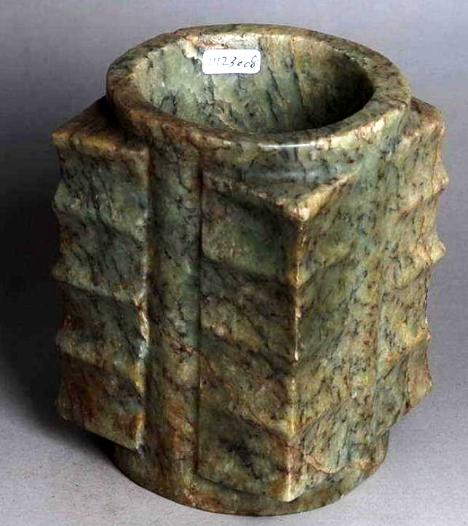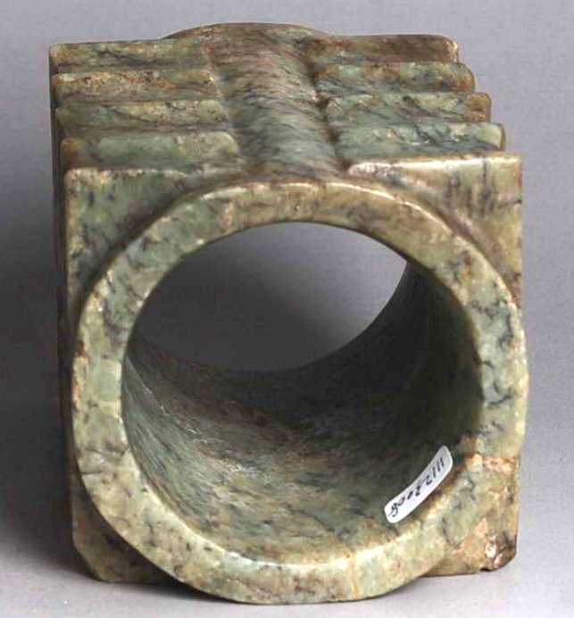
Jade yue axe, Late Neolithic Qijia culture (ca. 2400 - 1900 BCE), Northwest Longshan, height 13.5 cm., width to top 9.6 cm., width at bottom 9.5 cm.

The Qijia culture (2400 - 1900 BCE) was an early Bronze Age culture distributed around the upper Huang Ho region of Gansu (centered in Lanzhou) and eastern Qinghai, China. It is regarded as one of the earliest bronze-working cultures. However, it still remained within the Neolithic jade -working sphere and many of the graves display a highly evolved jade-working culture that contributed to the number of high status interments. The present jade cong is such an example of a ritual jade for which the Qijia were famed. The development of this particular type of cong by the Qijia was to introduce abstract patterning of the sides of what is known as the "bamboo" motif in equidistant, repeating ridges. This design development signifies a Qijia preference for geometric forms that characterizes ritual jades of Gansu Province, unlike the earlier cong designs of the Liangzhu Culture which incorporated animal and anthropomorphic masks into the imagery. An example excavated from the Houliugoucun site in Jingning, Gansu Province provides a comparable example (Gu 2005[15]: 35-36). However, the current example still shows the earlier Liangzhu penchant for making the top wider than the bottom.
References: Gu, Fang. 2005 (15). The complete collection of unearthed jades in China. Beijing: Science Press. v. 15: Gansu, Qinghai, Ningia, Xinjiang.

The second type of spirit invoked is those of the forces of nature. According to the sages, nature encompasses certain, defined numinous spirits (shen ). (Liji,“Ji fa,” ICS, 122.24.3) of mountains, forests, rivers, valleys, and hills from which can emanate clouds, wind and rain, and other phenomena and that there was "a proper hierarchy of offering sacrifice to these spirits with the ruler who possessed all under heaven able to sacrifice to the hundred spirits while the lords of the states able to sacrifice only to those spirits that were on his land. (Liji,“Ji fa,” ICS, 122.24.3) Certain elements in the cosmos (including everything from mountains to rain that had powers relevant to humans were included in this category. Their powers were made efficacious if sages could unlock access to their numinous essence.

The goal of sacrifice in the Liji is to transform all the participants through the offering of food and drink.
All recipients of sacrifice are transformed: ghosts into ancestors, capricious natural forces into hierarchically ordered spirits. The sacrificer is also placed in a new relationship to these transformed ancestors and spirits
for which he/she has a proper reverence and his/her position between humanity and the world of ancestral and
numinous natural powers renders him/her with a new source of power. He/she becomes the father/mother of the people through sacrifice that has a fundamental transformative efficacy in the social and cosmic realms.

